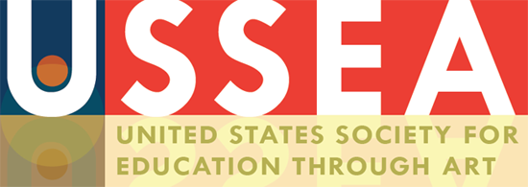

USSEA/InSEA Regional Conference Summer 2024
Hilton Santa Fe
Santa Fe, NM
June 13-15, 2024

Conference Theme:
Responding to Cultural Crises: Action, Creativity, and Empowerment
The purpose of the conference is to inspire attendees to acknowledge cultural crises and develop alternative perspectives for addressing them. Our goal for participants is to arrive at relevant plans of action for resolution and propel shifts in differentiated curricula & pedagogy toward hearing silenced voices and empowering cultural agencies.

Special sessions include:
- Artist Sally Blakemore
- Authors’ Round Table
- Panelist’s Choice Workshop or Lecture
Keynote panels include:
- Artist Panel
- Museum Panel
- Pedagogue Panel

Call for Proposals now open!!
Visit www.ussea2024.com for submission criteria
For submission information, contact Borim Song, PhD at songb@ecu.edu

For more conference information, contact one of your conference co-chairs:
Mara Pierce, PhD (USSEA President) at ussea2023@gmail.com
or Angela LaPorte, PhD at alaporte@uark.edu

